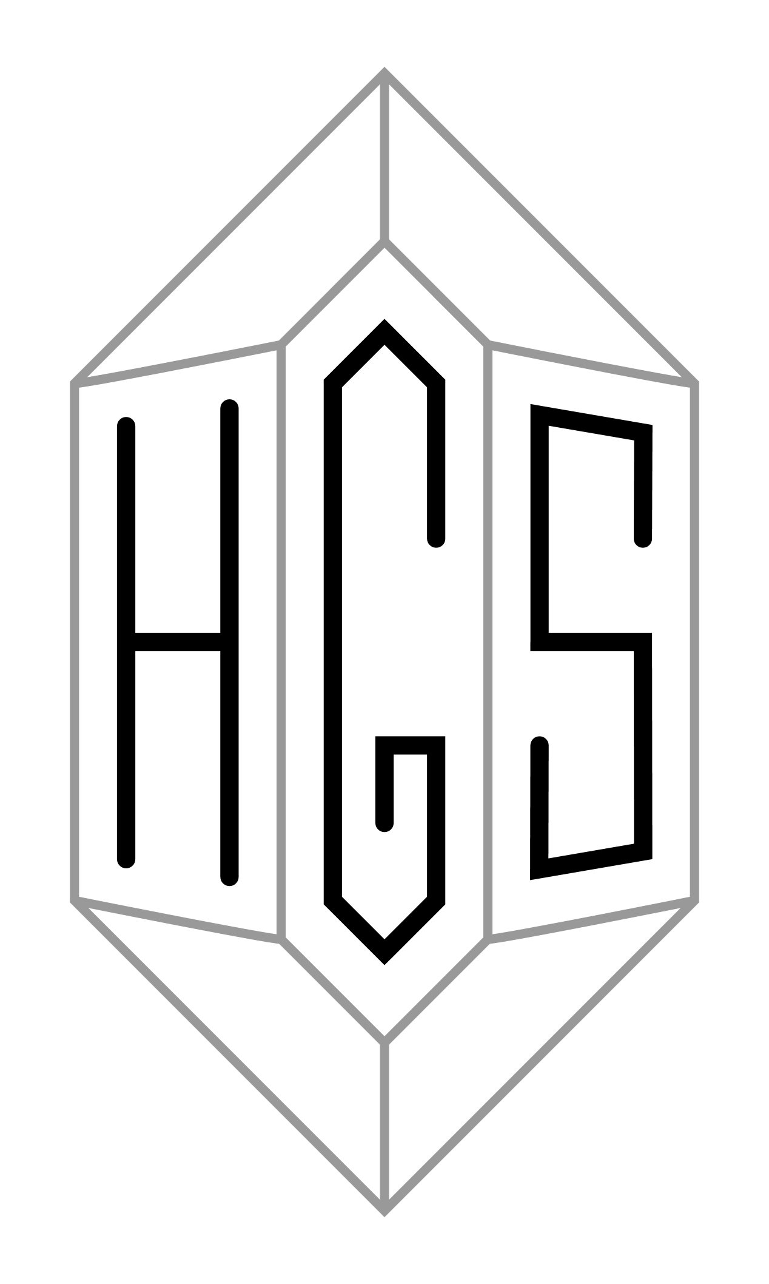 | THE HIGHLAND GEOLOGICAL SOCIETY  Scottish Charity No. SC004427

May 2020
Dear Members,

It looks as though it will be some time before we are able hold our usual summer field trips and winter lectures again. As a result, and like many other societies, we have been investigating using Zoom to offer suitably ‘socially distanced’ substitutes.

Our plan is to offer three ‘virtual field trips’ (in May, June and July) using Zoom technology. The leaders will be our own members, and these will be something of an experiment so that we can all learn about the approach. For our winter programme we anticipate that at least the lectures in October, November and December will be delivered over Zoom and have planned with the speakers on this basis. This may or may not prove to be necessary for the remainder of the programme as well. The revised programme is set out below.

Some of you will have used Zoom before and will be familiar with it, and we will issue the meeting number and password by email shortly before each ‘field trip’ and lecture. Note that you may need to update to Zoom version 5.

If you haven’t used Zoom before, we will send a link which will prompt you to download the program/app and take you directly to the meeting. It will run on most types of laptop, desktop, tablet, iPad and even smartphone, and if you have a choice we recommend that you use the device with the largest screen. You do not need to set up a Zoom account to join a meeting. We’ll open the first meeting in good time to allow for all of this, but if you would prefer to do the set up and experiment with it sooner, please contact Alan, letting him know what device you plan to use, and he will help you through this.

Proposed dates for Zoom talks, all starting at 19:30:

Wed 27th May, Andy Moffat: "A Big Splat at Clachtoll. Hydro-fractured Lewisian Gneiss. Rock fall impact or fault induced Torridonian mud-filled fractures?"

At Clachtoll, a beach exposure of Lewisian Gneiss shows a complex of spectacular red, mud filled fractures at beach level. Clearly, soft Torridonian muds have been injected under high pressure into the competent gneiss. Injection has been under such pressure that the fractures have frequently propagated and the gneiss locally brecciated. The upper surface of the gneiss exposure also contains red mud-filled fractures that are notably different from the fractures lower down. Nearby is a fault with Torridonian occurring on the other side of the small bay. Is this a factor in the gneiss fracturing? Well, yes and no. The mechanism responsible has been the subject of much debate - until recently.

The illustrated talk explains the unique hydro-fracturing in relation to the local geology.

Wed 24th June, Alan Thompson: The North Coast of Caithness/Sutherland. A Virtual Field Trip to examine “The nature of the sub-Devonian unconformity and basin marginal deposits of the Orcadian Basin”

Last year Anne and I offered to run a ‘self-led’ excursion to the north coast of Caithness, centring this on Excursion 5 in ‘Excursion Guide to the Geology of East Sutherland and Caithness’ (Nigel Trewin). In preparation we went to the area for a week in early December 2019 and did a recce of the main locations. This talk is in part a virtual field trip, in part the story of the recce, and in part a taster for the time when we will run the real field trip.

Wed 22nd July, Dave Longstaff: A trip down the River Findhorn.

In Iieu of the previously planned field trip this will be a look at the River Findhorn highlighting the geology, geomorphology and glacial effects to be found along the river and will include a brief description of the "Muckle Spate" of 1829.

It may be possible to arrange a further event in August or September. If so, details will be circulated in due course.

Winter Programme

Wed 7th October, A Lewisian Perspective: The Basement of the Earth, Professor Frank Rennie, UHI.

Wed 11th November, The Rise and Fall of the Dinosaurs, Dr Steve Brusatte, University of Edinburgh.

Wed 16th December, Building Stone: Making the right choice, Professor Peter Scott, Emeritus Professor, Camborne School of Mines.

Wed 13th January, In the footsteps of Hugh Miller: New fish finds from the Carboniferous and Jurassic of Scotland, Dr Tom Challands, University of Edinburgh.

Wed 24th February, Annual General Meeting

Wed 17th March, The Dating Game: One Man’s Search for the Age of the Earth, Dr Cherry Lewis, University of Bristol.

Further details of these talks will follow. All will take place at 19:30. As indicated, it is anticipated that the first three at least will be delivered over Zoom.

Shetland Field trip 2021

We have been able to rebook the Shetland week for 2021, and in summary the programme will be:

Wed 2 June overnight ferry Aberdeen to Lerwick
Th, F, Sa, Su 3 - 7 June stay 4 nights at Bridge End Outdoor Centre
M, Tu, W 7 - 10 June stay 3 nights at Saxa Vord on Unst
Th 10 June overnight ferry to Aberdeen, arriving on the morning of Fri 11 June

We had ten participants signed up for the Shetland week 2020, and we anticipate all will wish to go in 2021. That will leave four more spaces available, and if anyone else among you would like to come would you please let Anne Cockroft (hgssec@gmail.com) know, by the end of May if possible?

Offprints about M Forster Heddle

Hamish Johnston has a batch of offprints of his chapter “M. Forster Heddle: an intimate friendship” published last year by the Geological Society, London, in their “Aspects of the Life and works of Archibald Geikie”.

He will be very happy to send a copy, gratis, to any member who wants one if they send him a stamped, addressed envelope - which must be A4 size with large letter stamp. He would much prefer that the booklets get ‘out there’ rather than gather dust in his house. His home address is
23 Macleod Road, Balloch, Inverness IV2 7JW.

Items of interest, geological websites

Geol Soc lectures and library:-
https://www.geolsoc.org.uk/Library-and-Information-Services/Virtual-Library/additional-online-resources-covid-19

Geologists Association: Geology from your sofa
https://geologistsassociation.org.uk/sofageology/

Palaeocast podcasts:-
https://www.palaeocast.com/category/mesozoic/
Angus Miller continues to give online lectures through Zoom:-https://mailchi.mp/9a527bccd48a/geowalks-in-9319550
A recently published paper on Henry Cadell’s experiments into mountain building:-https://sp.lyellcollection.org/content/early/2020/03/04/SP490-2019-142
An excellent, free, online resource on rock forming minerals was released a month ago:-https://pubs.geoscienceworld.org/books/book/952/An-Introduction-to-the-Rock-Forming-Minerals
Research paper on rock fall impact into wet sediments at Clachtoll:-
http://etheses.dur.ac.uk/13350/1/Killingback_MScR_thesis.pdf

The Scottish Geology Trust
http://www.scottishgeologytrust.org/

Other Scottish geological societies websites

Aberdeen Geological Society
http://www.aberdeengeolsoc.org.uk/

Edinburgh Geological Society
https://www.edinburghgeolsoc.org/

Glasgow Geological Society
https://geologyglasgow.org.uk/

Open University Geology Society
https://ougs.org/

CONTACT INFORMATION:
Chairman: Stephen Young 01349 864141 sstyoung84@gmail.com
Secretary: Anne Cockroft 01463 238992 hgssec@gmail.com
Treasurer: Alan Thompson 01463 238992 alanrossthompson@hotmail.com

